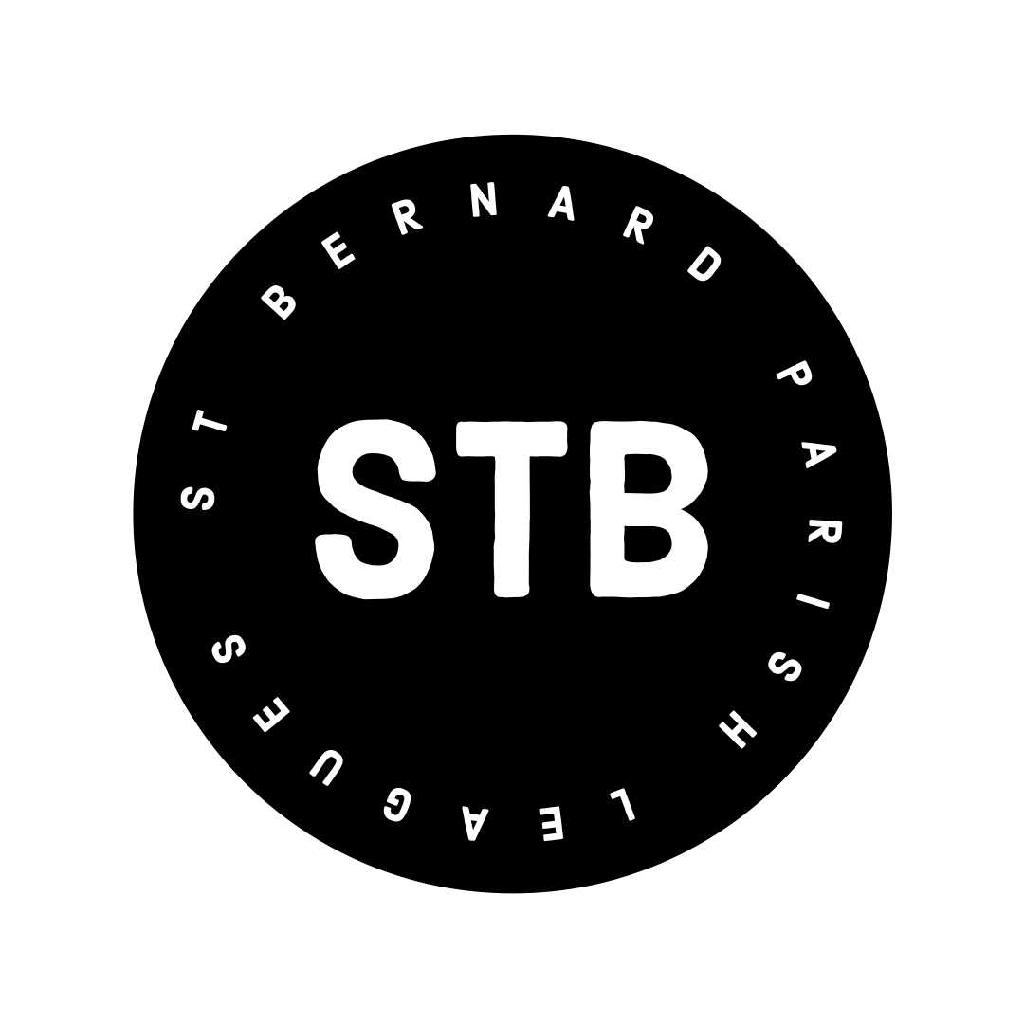
STB LEAGUES

Adult Co-Ed CabbageBall Rules

GENERAL RULES
- PLAY AT YOUR OWN RISK.
- Players must be at least 18 years old to participate in this league.
- Games will be played at Val Riess Sports Complex, in Chalmette.
- No smoking is allowed on the fields.
- Val Riess does not allow ice chests, sunflower seeds, or peanut butter to be brought into the park. St. Bernard Parish Recreation Department reserves the right to enforce this rule.
- Dugouts are expected to be cleaned by teams after their game.
- Cleats, tennis shoes, or other athletic shoes must be worn on the field. No metal spikes, slippers, bare feet, or bare socks.
- Batting gloves are allowed. Fielding gloves will be allowed when the temperature is 56 degrees or lower.

ELIGIBILITY
- You must be at least 18 years old to play in this league.
- All members of any high school sports program are ineligible to play in this league, even if they meet the age requirement.
- The preceding eligibility rules (a,b,c) are set by the STB Leagues and/or LHSAA. League directors have the responsibility to remove ineligible players from the game at any time during play. If providing identification is an issue, player will be removed from the game based upon judgement.
- A player must play in and be recorded in the lineup of the official scorebook in at least two (2) games with the team whose roster they are listed on to qualify for the playoffs with that team.
- Rosters will be turned in by the 3rd week of games. Exceptions will only be considered in special circumstances, such as injury.

FEES
- The fee for the league is $400.00 per team- the winner of each division the previous season will have their team fees waived in the next calendar season.
- Teams pay cash for the scorekeeper and umpire each game: $35.00 per team.
- $70 deposit for forfeits. (explained below)
- All league fees are payable by cash, check, or payment apps (i.e. Venmo or PayPal).
Checks made out to Cash or John Stogner.
- If you require a written receipt, request it from a league director.
- All league fees must be paid by the 3rd week of the current season, or the team will not be allowed to play on the 4th week unless the team’s payment is received before game time.

FIELD

- Bases are 50 feet.
- Pitching mark is 35 feet.
- The pitching height will be 3’-10’, with a slight arc.
- There will be a strike zone mat fitted to the back of the plate. If the ball hits either home plate or the strike zone mat it WILL be a strike. In the absence of a strike zone mat, balls and strikes will be determined by the umpire.
- Fielding positions must be alternated man, woman, man, etc.
- Fielders will be allowed to shift to open positions when a team is playing with less than 10, but gender alternation is still required.
- Outfielders must remain in the outfield until the batter makes contact with the ball.
a. If batter or base runners are put out due to a play resulting from an outfielder being on turf before the contact, penalty is a free base for the batter and each runner on base is awarded a free base.
- Outfielders may not cross home plate-second base line until ball is hit. (i.e. left center must be on the left side of line and right center must be on the right side of the line)

SCHEDULE
- The schedule is subject to change due to weather related issues or any other unforeseen circumstances.
- Rain outs will be added to the end of the regular season schedule, or could be dropped from the schedule.
- Playoffs will be seeded based on season standings. Ties will be separated first by head to head winner, then run differential, then runs scored.
- 1st place winner of each division could be asked move up a division. We will consider moving teams down a division as well, per request at the end of each season.
- We play on turf. Weather decisions will not be made prior to 5:30pm. Communication with team captains will be made after that time.
- During playoffs, teams should be prepared to play with changing times on short notice. The bracket could be updated multiple times a day and/or up to game time.

ROSTER AND SUBS
- Team captains must submit a roster with at least 10 players, 5 minimum women, by the 3rd week of the season.
- There is no maximum roster size.
- IT IS YOUR RESPONISBILTY TO MAKE SURE YOUR PLAYERS ARE NOT ON
ANYONE ELSE’S ROSTER. Talk to your players and make sure they are not committing to more than one team at a time.
- ONE or TWO SUBS can be used in a game, max. (1 GUY, 1 GIRL, OR 2 GIRLS)
- No subs allowed at all in playoff games.
- Players from the team’s official roster, who have played the minimum 2 games are the only eligible playoff players.
- If 5 legal players from the official roster are not present to play at game time, the game is declared a forfeit, with paid forfeit fee, and no umpire will call game, because teams can only use 2 subs, per these rules.
- Divisional Rules: Players are allowed to sub in specific divisions based on the division of the team whose roster they are on in the current season.
  - Violations of this rule are protestable as outlined below.
  - Guys: Are allowed to sub in their own division, and any division higher. Guys may not sub down in division.
  - Ladies: Are allowed to sub in their own division, and any division higher, as well as one division lower.
  - For example : Division A ladies can sub in division A & B. Division B ladies can sub in Division A, B, C. Division C & D ladies can sub in Division A, B, C, D.
  - Keep in mind subs are not permitted to play in playoff games.

GAME PLAY
- Infield Fly rule applies in this league.
- No stealing or leads. Leaving the base after being checked, and without the ball being put in play, will result in an out.
- Open palm pitching only to female batters. No spinning.
- No sliding. Runners must stay as vertical as possible.
- Runners may not reach for a base with their hand.
- Courtesy runner will be allowed at any time. The last batted out of the same sex will be considered the legal courtesy runner.
- One courtesy runner is allowed per gender, per inning.
- Lead runners must be checked in the baseline.
  - Any throw towards a player besides the pitcher on the pitcher’s mound, removes any previous check of runners.
  - Automatic check is issued when the ball is on the pitcher’s mound, or when umpire calls “TIME”.
  - All checks are governed by the umpire’s judgement.
- These rules are considered full and complete as stated, and any rule not addressed here in these rules will default to NSA Coed Slowpitch Rules, with some exception.

TIME LIMITS-INNINGS
- All games are 7 innings or 60 minutes.
- TIES: In the event of a tie at the end of 7 innings, play will continue only if there is time left on the game clock. The game will be played until the time is expired and the inning is completed. – regular season games can end in ties.
- Official game time will be recorded after 4 innings of play.
- RUN RULE will apply as follows: 15 runs after 3 innings, 12 runs after 4 innings, and 10 runs after 5 innings.
- Submit a lineup to the scorekeeper 10 minutes prior to the start of the game.
- Umpire fees are due to the umpire BEFORE each game. Official game time will begin at the captain’s meeting at the plate, but game play will not be allowed until fees are paid. If a team causes a 5 min delay, forfeit may be called.
- PLAYOFFS ONLY, must have a winner. No international tie breaker rules.
- Championship game will be played with no time limit. 7 innings will be played.
- Championship game: home team is the undefeated team. IF-game home team is decided by coin flip.

LINEUPS-BATTING
- BEFORE each game teams must submit a lineup with no less than 7 players to be considered a legal team.
- Each team may bat up to 12 batters.
- Lineups should reflect names that can be matched to the official roster. Be mindful of nicknames.
- A legal game can be played with 7 or more players. No more than one guy more than girls. For example: 4 guys/3 girls. 5 guys/4 girls. 5 guys/5 girls.
- Batting positions must be alternated. Two men batting back to back will result in an automatic out.
- There is no penalty for batting girls back to back.
- NO bunting, chop swings, or half swings. This will result in a dead ball and batter being called out. UMPIRE’S JUDGEMENT.
- One warning of throwing bat. Next time batter will be called out. UMPIRE’S
JUDGEMENT.
- Men must bat opposite of their natural hand. If a guy is switched to the opposite hand, he cannot be switched back during the same game.
- A player is allowed 1 foul ball after 2 strikes, the next attempt MUST be put in play or the batter is out.
- There will be no penalty for stepping out of the batter’s box, unless batter steps on plate or mat, which results in an out.
- If a man is walked, intentionally or otherwise, he will be awarded first base. The batting position following the walk will be a woman, and she will be offered the choice to walk or to bat.
a. If there is an empty batting position (where a girl should be) following the walk, that batting position will be scored as an Out after the result of the man advancing one base.
- Baseball bats are not allowed.
- Bats need to be legal. Teams can question a bat by bringing it to the umpire’s attention, and umpire and league directors will make the final decision on the bat being legal or not.
- A legal bat is a softball bat and must have a 2 ¼ barrel. Any other bat is illegal.
- If a batter is found to be using an illegal bat, they will be asked to use a different bat, or be called out.
- Once a player is substituted out of the lineup, they are ineligible for the remainder of the game.

EJECTIONS, MISBEHAVIOR
- No alcohol allowed on playing field.
- No foul language.
- No drunkenness.
- No fighting.
- Regarding a-d: Players will be issued ONE warning, after the warning, the player will be asked to leave the park if behavior continues.
- Smoking is allowed in designated areas. No smoking allowed on the fields or in the dugouts.
- Players ejected from a game have 2 minutes to leave the field or the team will forfeit that game; the automatic result is next-game suspension. Subsequent same-season game ejections will result as follows: 2nd ejection-2 game suspension. 3rd ejection- league ejection.
- Players ejected from the park will have 5 minutes to the leave the park or the team will forfeit the game. A decision regarding further consequences will be made based on the actual incident.
- No fighting is allowed. If a player is ejected for fighting they will be ejected from the league.
- Harassment of umpires will not be tolerated.

PROTEST
- All Umpire Judgment calls are FINAL and CANNOT be protested. Harassment of an umpire will not be tolerated.
- If a protest is made on a player, that player may be required to produce a picture ID to verify who they are and/or their age. If they are unable/unwilling to provide, they may still be removed from a game based on league director’s judgement.
- Playoffs only: if a player is found by protest to be playing illegally, the game will be declared a forfeit loss.
- League directors reserve the right to remove players from a game who are violating any eligibility rules, without protest.
- Official Protests during regular season games will be handled using these actions:
  - Team captain must notify home plate umpire of the intent to protest. Umpire will summon a league director or supervisor.
  - These are the only valid reasons for protests:
    - Rule interpretation
    - Player eligibility
  - These are the only possible protest results:
    - Rule interpretation is clarified and/or corrected
    - Ineligible players will be required to leave the game.
  - Protests regarding eligible players can only be made prior to the first pitch of the 4th inning.
    - Exception: If the protest is related to a player who enters the game after the start of the 4th inning.
  - Protests regarding a rule interpretation can only be made until the next pitch is thrown after the call is made.
- Protests during Playoffs will be handled using these actions:
  - There will be a $25 protest fee. This fee will be returned if a team’s protest is found to be warranted.
  - Team captain must notify home plate umpire of the intent to protest. Umpire will summon a league director or supervisor.
  - The only protests considered:
    - Rule interpretation
      - This protest can only be made until the next pitch is thrown after the call in question is made.
    - Player eligibility
      - Protests regarding eligible players can only be made prior to the first pitch of the 4th inning.
      - Exception: The player in question enters the game after the 4th inning. In which case you will have until the first pitch of the next inning, of which they entered, is thrown.
  - The only possible protest results:
    - Rule interpretation is clarified and/or corrected.
    - If a team is found to be in violation of player eligibility rules by official protest, the game will be declared a forfeit.
    - If a team’s protest is found to be warranted, the protest fee will be refunded.

Forfeits
- Any team that forfeits a game will be charged a forfeit fee of $35. This is paid by a
league director to the umpires/scorekeeper out of the team’s forfeit deposit.
- All forfeited games will have the result of 7-0.
- Along with the team fees there is a $70 forfeit deposit for new teams.
- If a team forfeits a game, the forfeit fee will come out of the deposit.
- If a team has no forfeits for the season, that team’s deposit will carry over for the next season for the same team.
- After two forfeits in one season, a team will be considered for removal from the league.
- If a team uses a forfeit fee, it must be replaced by their next game.
- It is the captain’s responsibility that rosters should be turned in to a league director by the 3rd week of the season. If a player eligibility is in question by an opposing team, and there is no official roster on file, it could result in a forfeit.
For any questions, concerns, or additional information contact John Stogner Jr @ 504-810-3074
STB Leagues Co-ed Cabbageball Rules: revised 01/05/2022

